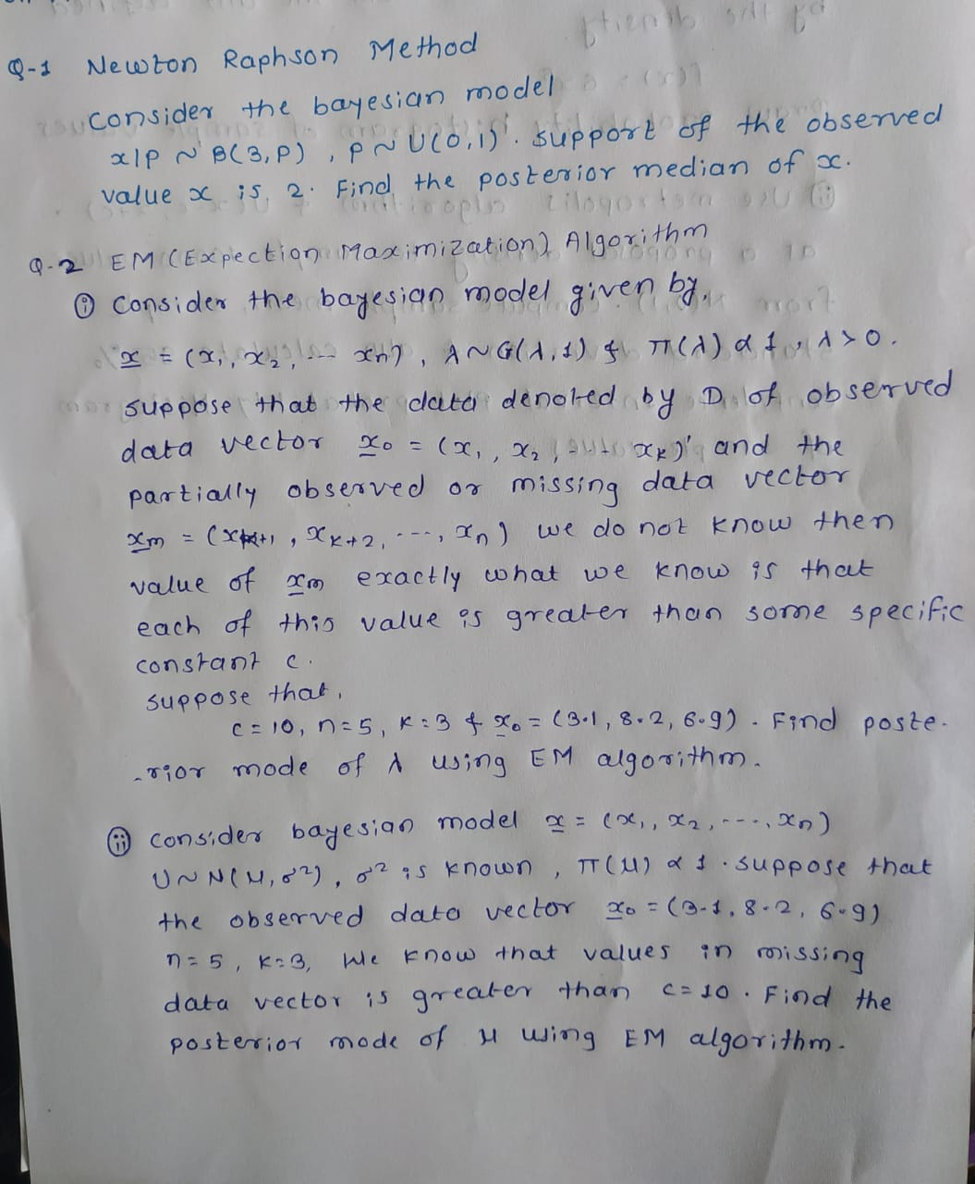

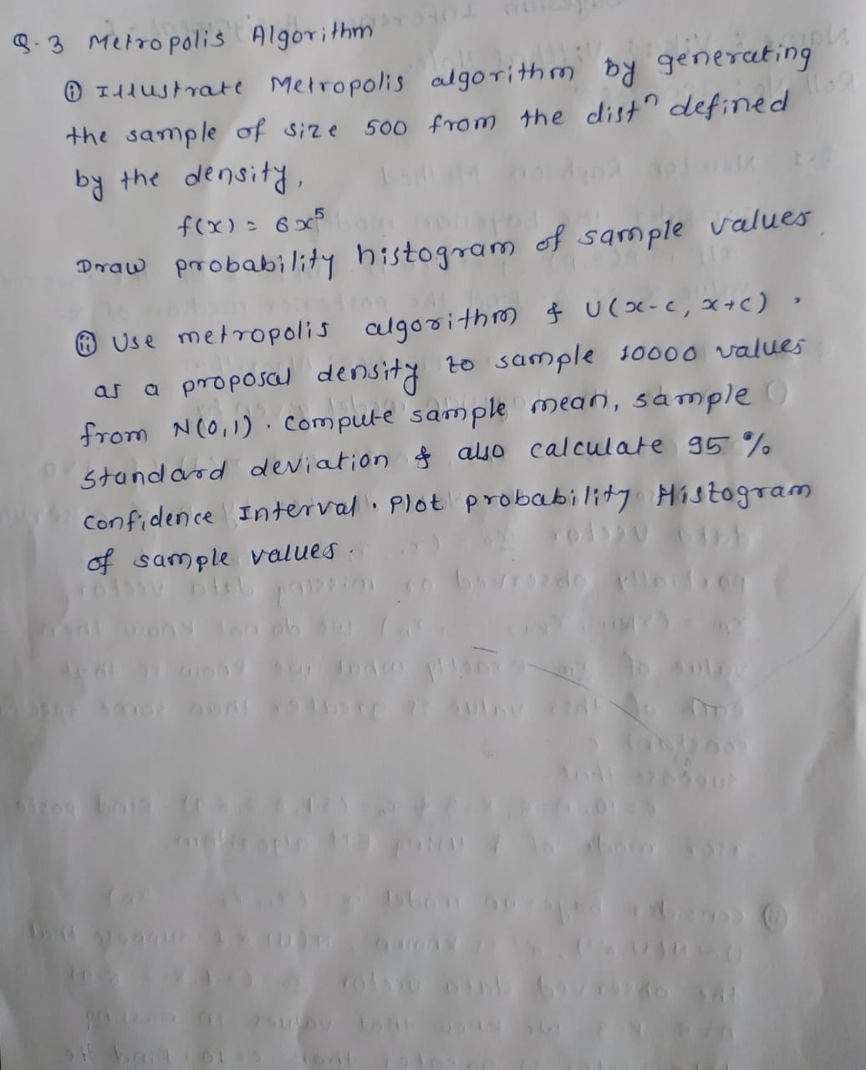

**> #Question1**

**> #Newton Raphson Algorithm**

>

> p=2/3 ; #We took initial guess as a 2/3 because 2/3 is estimated value of phat=xhat/n=x/n=2/3

> gy=function(p)

+ {

+ return(3*p^4-4*p^3+1/2)

+ }

> g_y=function(p)

+ {

+ return(12*p^3-12*p^2)

+ }

> k=0

> for(i in 2:1000)

+ {

+ p[i]=p[i-1]-(gy(p[i-1])/g_y(p[i-1]))

+ k=k+1

+ a=abs(p[i]-p[i-1])

+ if(a<0.000001)

+ {

+ print(p[i])

+ k

+ return(0)

+ }

+ }

[1] 0.6142724

> k

[1] 3

> print(paste("No. of iterations used",k))

[1] "No. of iterations used 3"

> print(paste("Posterior median of p",p[i]))

[1] "Posterior median of p 0.614272431867611"

>

>

>

>

**> #EM Algorithm:**

**> #Example 1**

> n=5

> L=1

> c=10

> k=3

> x01=c(3.1,8.2,6.9)

> x0t=sum(x01)

> d=0.000001

> for(i in 2:100)

+ {

+ L[i]=(n/(x0t+(n-k)*(c+(1/L[i-1]))))

+ if(abs(L[i]-L[i-1])<d)

+ {

+ print(paste("No of iteration",i))

+ print(paste("Posterior mode ",L[i]))

+ break;

+ }

+ }

[1] "No of iteration 14"

[1] "Posterior mode 0.0785345170595558"

>

>

>

**> #Example 2**

> n=1000

> n1=5

> k=3

> x0=c(3.1,8.2,6.9)

> x0t=mean(x0)

> c=10

> sig=1

> mu=3

> d=0.000001

> e=function(p)

+ {

+ p+sig*(dnorm((c-p)/sig))/(1-pnorm((c-p)/sig))

+ }

> for(i in 2:n)

+ {

+ mu[i]=(k*x0t+(n1-k)*e(mu)[i-1])/n1

+ if(abs(mu[i]-mu[i-1])<d)

+ {

+ print(paste("No of iteration",i))

+ print(paste("Posterior mode ",mu[i]))

+ break;

+ }

+ }

[1] "No of iteration 7"

[1] "Posterior mode 7.77976784180798"

>

>

>

**> #Metropolis algorithm**

>

**> #Example 1**

> A=function(a,b)

+ {

+ (a/b)^5

+ }

> c=0.1

> #Sample size

> n=500

> x = c() # to store values coming from target

> y = c() # to store values coming from proposal

> x[1]=0.5

>

> # initial value

>

> for (i in 2:n)

+ {

+ y[i]=runif(1,x[i-1]-c,x[i-1]+c)

+ ap=A(y[i],x[i-1])

+ ap=ifelse(ap>=1,1,ap)

+ ap=ifelse(y[i]<0,0,ap)

+ ap=ifelse(y[i]>1,0,ap)

+ u=runif(1,0,1)

+

+ x[i]=ifelse(u<=ap,y[i],x[i-1])

+ }

> x

[1] 0.5000000 0.4147034 0.4147034 0.3672182 0.4454041 0.4260132 0.4260132 0.3995461 0.3995461 0.3995461 0.4590063

[12] 0.4806764 0.4666218 0.4770016 0.3817268 0.3817268 0.3582108 0.3826061 0.4624155 0.4530025 0.4938426 0.5579016

[23] 0.6236293 0.7165078 0.6318678 0.6318678 0.6318678 0.6872794 0.6512653 0.6281736 0.7226040 0.7007604 0.6376126

[34] 0.6786944 0.7131922 0.6259918 0.7116746 0.6736126 0.6338041 0.5785940 0.5658123 0.4963685 0.5233707 0.5321034

[45] 0.5321034 0.4497893 0.4497893 0.4310130 0.4013251 0.4902990 0.4884487 0.5416886 0.5696693 0.5705385 0.5877985

[56] 0.6844536 0.6948056 0.7602846 0.6879462 0.6864980 0.6864980 0.7020361 0.7770887 0.7190496 0.7190496 0.6581108

[67] 0.7052960 0.7052960 0.6954783 0.6507822 0.6580744 0.6261862 0.6944172 0.7024801 0.6920940 0.7065643 0.6429834

[78] 0.5765486 0.5055246 0.5728021 0.5728021 0.6431750 0.6764495 0.6764495 0.6277803 0.7020133 0.7020133 0.7267163

[89] 0.7687783 0.7924195 0.7356049 0.7260534 0.6814020 0.6752856 0.7564694 0.7501972 0.7083375 0.6592375 0.6905619

[100] 0.6569285 0.6642103 0.6642103 0.5757424 0.5757424 0.6623858 0.5981037 0.5981037 0.6676826 0.7337248 0.7337248

[111] 0.7129254 0.7129254 0.6575377 0.7296126 0.6341339 0.5506047 0.5136351 0.5136351 0.5136351 0.5136351 0.5699758

[122] 0.6386254 0.7316654 0.6559682 0.7077385 0.6614383 0.6614383 0.6216274 0.6353304 0.6861392 0.7142272 0.7470199

[133] 0.7665438 0.7665438 0.6748661 0.6748661 0.6748661 0.6745340 0.7723448 0.7348389 0.6845961 0.7321412 0.8143224

[144] 0.8620810 0.8188548 0.7210493 0.6315008 0.7134608 0.7625077 0.7938853 0.8325098 0.7978327 0.8081299 0.7182127

[155] 0.7182127 0.7198536 0.6401333 0.6712311 0.6712311 0.6769610 0.7400610 0.7485160 0.6979602 0.7710792 0.7796936

[166] 0.7729705 0.6878898 0.6596690 0.7465486 0.8440489 0.9176612 0.9176612 0.8267579 0.9224497 0.9224497 0.8333644

[177] 0.8738256 0.8727701 0.8418400 0.7628930 0.7560954 0.7560954 0.7245000 0.7245000 0.7245000 0.7023262 0.6614707

[188] 0.6783079 0.6002128 0.6776669 0.6465306 0.7260883 0.7316862 0.7902387 0.7902387 0.7141579 0.6588551 0.6994860

[199] 0.6966475 0.7508750 0.7991438 0.7858837 0.6917316 0.7617286 0.7411128 0.7977427 0.8897183 0.8389227 0.8240770

[210] 0.7862059 0.8110462 0.7591463 0.7069481 0.7604399 0.8282982 0.8188248 0.7869976 0.8740729 0.8970165 0.9337176

[221] 0.9337176 0.9337176 0.8979576 0.8929661 0.8017891 0.8017891 0.8112576 0.8318430 0.9198379 0.9235451 0.8902791

[232] 0.9029663 0.8763860 0.8371104 0.8371104 0.8713642 0.8976074 0.9077750 0.9225137 0.8857865 0.9746427 0.9746427

[243] 0.9746427 0.9351848 0.9646447 0.9646447 0.9646447 0.9646447 0.9166115 0.8314021 0.8821612 0.8731273 0.8731273

[254] 0.8105442 0.8105442 0.8064149 0.7620174 0.7620174 0.7480895 0.7480895 0.7315645 0.7587086 0.7961220 0.7961220

[265] 0.7961220 0.7449315 0.7188604 0.6825805 0.6139109 0.6365429 0.6921271 0.7670564 0.7670564 0.7790437 0.7878262

[276] 0.8315616 0.8533744 0.8147581 0.8491977 0.7835132 0.8459639 0.9413900 0.9413900 0.9413900 0.9413900 0.8520092

[287] 0.8661922 0.8737921 0.8413152 0.8646348 0.8946532 0.8899078 0.8875767 0.8875767 0.8875767 0.9147602 0.8984435

[298] 0.9844198 0.9925126 0.9925126 0.9925126 0.9515408 0.9515408 0.9552059 0.9533155 0.9559025 0.9559025 0.8847117

[309] 0.8359301 0.8721609 0.8721609 0.8043236 0.8043236 0.8043236 0.7696696 0.8124410 0.8938099 0.8931803 0.9732973

[320] 0.9862756 0.9907598 0.9528609 0.9718024 0.8814925 0.8745886 0.9479110 0.9479110 0.9479110 0.9479110 0.9479110

[331] 0.9841244 0.9727212 0.9727212 0.9175926 0.9175926 0.8788526 0.8788526 0.9113028 0.9575022 0.9985740 0.9985740

[342] 0.9985740 0.9026087 0.9548628 0.8625498 0.8625498 0.8158565 0.8267880 0.8433398 0.8856398 0.9608569 0.9608569

[353] 0.9608569 0.9322255 0.9903615 0.9903615 0.9903615 0.9903615 0.9903615 0.9660480 0.9978828 0.9978828 0.9452256

[364] 0.9170354 0.9289358 0.9371291 0.8791126 0.8840932 0.8820698 0.9171423 0.9029029 0.9472249 0.8969890 0.9932329

[375] 0.9932329 0.9932329 0.9932329 0.9932329 0.9454177 0.9393300 0.8974399 0.8463018 0.9117512 0.9117512 0.9117512

[386] 0.9734877 0.9734877 0.9734877 0.9711706 0.9788886 0.9788886 0.9975978 0.9856584 0.9856584 0.9844927 0.9968826

[397] 0.9968826 0.9968826 0.9968826 0.9331435 0.9178491 0.9178491 0.9758144 0.9758144 0.8793266 0.8793266 0.8793266

[408] 0.8907796 0.9279018 0.9817310 0.9817310 0.9817310 0.9064700 0.8915444 0.8828913 0.8328112 0.8328112 0.7782475

[419] 0.8350833 0.7718787 0.7400432 0.7158160 0.7140966 0.7291277 0.7134956 0.7245853 0.6606128 0.6519015 0.5865194

[430] 0.5865194 0.5772593 0.5772593 0.6596313 0.6283320 0.6924361 0.7570472 0.8432879 0.8487920 0.8391604 0.9287126

[441] 0.9287126 0.8992427 0.8185630 0.7915637 0.8109706 0.8716084 0.9019176 0.9019176 0.9888652 0.9475048 0.8997735

[452] 0.8162763 0.8162763 0.7671845 0.8536585 0.8405640 0.7879298 0.7777645 0.8179847 0.9028986 0.9028986 0.9908231

[463] 0.9908231 0.9908231 0.9781305 0.9781305 0.9754400 0.9754400 0.9754400 0.9754400 0.8814484 0.9648489 0.8920887

[474] 0.9827264 0.9520786 0.9253465 0.9416066 0.9231044 0.8955069 0.8856698 0.9817116 0.9817116 0.9817116 0.9817116

[485] 0.9066698 0.8140916 0.8868693 0.8645994 0.8792034 0.9359556 0.9953935 0.9953935 0.9659190 0.9707531 0.9707531

[496] 0.9074683 0.9074683 0.9649274 0.9883593 0.9883593

> x=x[100:n];x

[1] 0.6569285 0.6642103 0.6642103 0.5757424 0.5757424 0.6623858 0.5981037 0.5981037 0.6676826 0.7337248 0.7337248

[12] 0.7129254 0.7129254 0.6575377 0.7296126 0.6341339 0.5506047 0.5136351 0.5136351 0.5136351 0.5136351 0.5699758

[23] 0.6386254 0.7316654 0.6559682 0.7077385 0.6614383 0.6614383 0.6216274 0.6353304 0.6861392 0.7142272 0.7470199

[34] 0.7665438 0.7665438 0.6748661 0.6748661 0.6748661 0.6745340 0.7723448 0.7348389 0.6845961 0.7321412 0.8143224

[45] 0.8620810 0.8188548 0.7210493 0.6315008 0.7134608 0.7625077 0.7938853 0.8325098 0.7978327 0.8081299 0.7182127

[56] 0.7182127 0.7198536 0.6401333 0.6712311 0.6712311 0.6769610 0.7400610 0.7485160 0.6979602 0.7710792 0.7796936

[67] 0.7729705 0.6878898 0.6596690 0.7465486 0.8440489 0.9176612 0.9176612 0.8267579 0.9224497 0.9224497 0.8333644

[78] 0.8738256 0.8727701 0.8418400 0.7628930 0.7560954 0.7560954 0.7245000 0.7245000 0.7245000 0.7023262 0.6614707

[89] 0.6783079 0.6002128 0.6776669 0.6465306 0.7260883 0.7316862 0.7902387 0.7902387 0.7141579 0.6588551 0.6994860

[100] 0.6966475 0.7508750 0.7991438 0.7858837 0.6917316 0.7617286 0.7411128 0.7977427 0.8897183 0.8389227 0.8240770

[111] 0.7862059 0.8110462 0.7591463 0.7069481 0.7604399 0.8282982 0.8188248 0.7869976 0.8740729 0.8970165 0.9337176

[122] 0.9337176 0.9337176 0.8979576 0.8929661 0.8017891 0.8017891 0.8112576 0.8318430 0.9198379 0.9235451 0.8902791

[133] 0.9029663 0.8763860 0.8371104 0.8371104 0.8713642 0.8976074 0.9077750 0.9225137 0.8857865 0.9746427 0.9746427

[144] 0.9746427 0.9351848 0.9646447 0.9646447 0.9646447 0.9646447 0.9166115 0.8314021 0.8821612 0.8731273 0.8731273

[155] 0.8105442 0.8105442 0.8064149 0.7620174 0.7620174 0.7480895 0.7480895 0.7315645 0.7587086 0.7961220 0.7961220

[166] 0.7961220 0.7449315 0.7188604 0.6825805 0.6139109 0.6365429 0.6921271 0.7670564 0.7670564 0.7790437 0.7878262

[177] 0.8315616 0.8533744 0.8147581 0.8491977 0.7835132 0.8459639 0.9413900 0.9413900 0.9413900 0.9413900 0.8520092

[188] 0.8661922 0.8737921 0.8413152 0.8646348 0.8946532 0.8899078 0.8875767 0.8875767 0.8875767 0.9147602 0.8984435

[199] 0.9844198 0.9925126 0.9925126 0.9925126 0.9515408 0.9515408 0.9552059 0.9533155 0.9559025 0.9559025 0.8847117

[210] 0.8359301 0.8721609 0.8721609 0.8043236 0.8043236 0.8043236 0.7696696 0.8124410 0.8938099 0.8931803 0.9732973

[221] 0.9862756 0.9907598 0.9528609 0.9718024 0.8814925 0.8745886 0.9479110 0.9479110 0.9479110 0.9479110 0.9479110

[232] 0.9841244 0.9727212 0.9727212 0.9175926 0.9175926 0.8788526 0.8788526 0.9113028 0.9575022 0.9985740 0.9985740

[243] 0.9985740 0.9026087 0.9548628 0.8625498 0.8625498 0.8158565 0.8267880 0.8433398 0.8856398 0.9608569 0.9608569

[254] 0.9608569 0.9322255 0.9903615 0.9903615 0.9903615 0.9903615 0.9903615 0.9660480 0.9978828 0.9978828 0.9452256

[265] 0.9170354 0.9289358 0.9371291 0.8791126 0.8840932 0.8820698 0.9171423 0.9029029 0.9472249 0.8969890 0.9932329

[276] 0.9932329 0.9932329 0.9932329 0.9932329 0.9454177 0.9393300 0.8974399 0.8463018 0.9117512 0.9117512 0.9117512

[287] 0.9734877 0.9734877 0.9734877 0.9711706 0.9788886 0.9788886 0.9975978 0.9856584 0.9856584 0.9844927 0.9968826

[298] 0.9968826 0.9968826 0.9968826 0.9331435 0.9178491 0.9178491 0.9758144 0.9758144 0.8793266 0.8793266 0.8793266

[309] 0.8907796 0.9279018 0.9817310 0.9817310 0.9817310 0.9064700 0.8915444 0.8828913 0.8328112 0.8328112 0.7782475

[320] 0.8350833 0.7718787 0.7400432 0.7158160 0.7140966 0.7291277 0.7134956 0.7245853 0.6606128 0.6519015 0.5865194

[331] 0.5865194 0.5772593 0.5772593 0.6596313 0.6283320 0.6924361 0.7570472 0.8432879 0.8487920 0.8391604 0.9287126

[342] 0.9287126 0.8992427 0.8185630 0.7915637 0.8109706 0.8716084 0.9019176 0.9019176 0.9888652 0.9475048 0.8997735

[353] 0.8162763 0.8162763 0.7671845 0.8536585 0.8405640 0.7879298 0.7777645 0.8179847 0.9028986 0.9028986 0.9908231

[364] 0.9908231 0.9908231 0.9781305 0.9781305 0.9754400 0.9754400 0.9754400 0.9754400 0.8814484 0.9648489 0.8920887

[375] 0.9827264 0.9520786 0.9253465 0.9416066 0.9231044 0.8955069 0.8856698 0.9817116 0.9817116 0.9817116 0.9817116

[386] 0.9066698 0.8140916 0.8868693 0.8645994 0.8792034 0.9359556 0.9953935 0.9953935 0.9659190 0.9707531 0.9707531

[397] 0.9074683 0.9074683 0.9649274 0.9883593 0.9883593

> hist(x,freq=FALSE)

> hist(rbeta(400,6,1),freq=FALSE,add=T,col = "red")

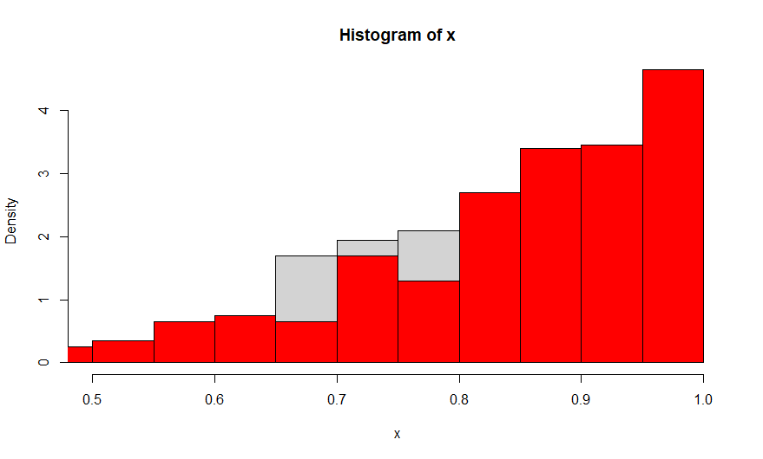

**> #Example 2**

> c=4

> #Sample size

> n=10000

> x = c() # to store values coming from target

> y = c() # to store values coming from proposal

> x[1]=0.5

> r=4 #tunning parameter

> # initial value

>

> for (i in 2:n)

+ {

+

+ y[i]=runif(1,x[i-1]-c,x[i-1]+c)

+ ap=dnorm(y[i])/dnorm(x[i-1])

+ ap=ifelse(ap>=1,1,ap)

+

+ u=runif(1,0,1)

+

+ x[i]=ifelse(u<=ap,y[i],x[i-1])

+ }

> x

[1] 0.500000000 -0.868167236 -2.325749084 -1.134699414 0.143719759 0.143719759 0.143719759 0.107609903

[9] 0.107609903 -0.811277706 0.801384488 0.147546658 0.147546658 -0.714301262 -0.714301262 -0.714301262

[17] -0.714301262 0.587293971 0.587293971 -0.141244827 -0.141244827 -0.141244827 -0.116658092 -0.261735301

[25] -0.261735301 -0.261735301 1.506082689 1.506082689 0.495922783 0.104751706 0.104751706 0.104751706

[33] 0.104751706 -1.346152792 0.664007282 0.664007282 0.664007282 -0.560987836 -0.560987836 1.944065038

[41] -1.758543750 1.726866059 1.726866059 1.726866059 -0.925881023 -0.715536566 -1.710781243 1.836898027

[49] 0.962994786 1.309193734 1.631846819 1.304564286 1.304564286 1.155646179 1.280652516 1.280652516

[57] 1.280652516 1.448687108 0.789386569 0.789386569 0.789386569 -0.673911687 -0.673911687 1.941235289

[65] 1.941235289 2.572006879 2.572006879 1.759628817 1.759628817 -0.048349246 -0.048349246 0.855683710

[73] 0.297619862 0.369356206 0.369356206 0.369356206 0.369356206 -0.296382464 -1.464631736 -1.464631736

[81] 0.063742019 0.063742019 0.063742019 0.063742019 0.063742019 0.063742019 0.063742019 0.939961493

[89] -1.332856394 1.587551510 1.587551510 1.587551510 1.587551510 1.587551510 1.587551510 1.686403899

[97] 1.686403899 0.221051438 -0.205155222 -0.765814671 -0.765814671 -0.266532850 -0.266532850 -0.266532850

[105] -0.266532850 1.143856654 0.983817425 -0.375946054 -0.375946054 -0.375946054 -0.375946054 -0.375946054

[113] -0.375946054 -0.375946054 -0.375946054 -0.375946054 1.242939943 -0.925512973 0.684367802 0.463280577

[121] 0.463280577 0.463280577 0.463280577 1.329172654 1.329172654 1.329172654 1.329172654 1.329172654

[129] 1.329172654 -0.291231340 -0.291231340 -0.291231340 -0.291231340 -0.291231340 -0.291231340 -0.291231340

[137] -0.291231340 -0.291231340 0.703126747 0.703126747 0.703126747 1.111456944 1.111456944 1.111456944

[145] 1.111456944 0.711092426 0.711092426 0.711092426 1.574689837 1.574689837 -1.848736268 -0.785646992

[153] 0.906179396 0.906179396 0.906179396 0.906179396 -1.006158704 -1.006158704 -1.006158704 -0.184130214

[161] -0.184130214 1.465255409 1.465255409 2.672488891 2.772604296 2.772604296 -0.559410647 0.866130156

[169] 0.866130156 0.866130156 1.100094983 -0.389308585 -0.389308585 -0.389308585 -0.389308585 -0.389308585

[177] -0.541055482 -0.541055482 -0.541055482 -0.534687396 -0.534687396 -0.534687396 -0.534687396 -0.534687396

[185] -0.714850316 0.151724244 -0.549992878 -0.549992878 -0.740258958 -0.740258958 -0.740258958 -0.740258958

[193] -0.740258958 -0.740258958 0.840480294 0.840480294 1.248115756 1.248115756 1.248115756 -0.803386426

[201] -0.803386426 -2.737048499 -2.737048499 0.228745947 0.415553505 0.415553505 0.415553505 0.017279243

[209] 0.017279243 0.017279243 0.017279243 0.017279243 -2.563598106 0.168341808 0.168341808 0.168341808

[217] 0.168341808 0.168341808 0.168341808 0.332336407 0.332336407 0.332336407 0.332336407 0.650133697

[225] 0.650133697 0.650133697 0.650133697 0.650133697 0.337768748 0.337768748 0.337768748 0.337768748

[233] 0.337768748 0.337768748 -0.743987147 -0.743987147 -0.743987147 0.345857482 -0.800924994 2.674892785

[241] 1.006614104 -1.397605341 -1.499545112 -1.499545112 0.396572132 0.872437073 -1.659712976 -1.659712976

[249] -1.659712976 -1.659712976 -1.659712976 -1.659712976 -1.000155393 -0.601798333 -0.601798333 -0.635889888

[257] -0.635889888 -0.635889888 0.543771716 0.543771716 0.513331387 0.513331387 0.513331387 0.513331387

[265] 0.513331387 0.513331387 0.513331387 0.513331387 0.513331387 0.513331387 0.513331387 0.328059418

[273] 0.328059418 -2.345540654 -1.462353563 0.535149276 0.535149276 0.535149276 0.535149276 0.535149276

[281] 0.535149276 -0.791765615 -0.791765615 1.888001518 1.888001518 -0.217144571 -0.217144571 -1.246236991

[289] -1.246236991 0.981667340 0.981667340 0.981667340 0.981667340 0.981667340 0.981667340 0.196118660

[297] 0.196118660 -1.165141637 -1.165141637 -1.165141637 2.126785267 2.126785267 1.550184885 -0.997990226

[305] -0.997990226 -0.997990226 -0.997990226 -0.997990226 -0.997990226 -0.997990226 -0.997990226 0.288732689

[313] 0.288732689 0.288732689 0.288732689 0.288732689 0.288732689 0.288732689 0.288732689 0.288732689

[321] -0.876408637 1.463242061 1.463242061 1.463242061 1.463242061 -0.566468190 -0.566468190 -0.566468190

[329] -0.566468190 -0.566468190 -0.566468190 -0.566468190 -0.331516286 1.025306713 1.025306713 1.025306713

[337] -0.581875615 -0.581875615 -0.581875615 -0.581875615 -0.581875615 0.227130260 -0.140228940 -0.606519265

[345] -0.606519265 -0.606519265 -0.606519265 -0.606519265 -0.606519265 -0.763395524 -0.763395524 -1.225679474

[353] -1.225679474 -1.173604941 -2.760130679 -2.402711967 -2.162309512 -2.292063899 -2.292063899 -2.327595517

[361] -2.327595517 1.059181172 0.659905601 0.659905601 1.146404048 -0.863111662 -0.863111662 -0.863111662

[369] -0.863111662 -1.233032528 -1.233032528 -1.233032528 1.189491291 1.189491291 0.611753093 0.611753093

[377] -0.884008428 -1.462536691 -1.462536691 -1.462536691 -2.000496054 -2.000496054 -2.080598375 -2.080598375

[385] -2.080598375 -2.080598375 -2.080598375 -2.080598375 0.443587169 0.515939582 0.515939582 0.515939582

[393] -1.294969419 -1.294969419 -1.294969419 -1.294969419 -0.890509140 -0.740887463 -0.740887463 -0.740887463

[401] -0.740887463 -0.740887463 -0.740887463 -0.740887463 -0.740887463 -0.740887463 -0.740887463 -0.740887463

[409] -0.740887463 -0.740887463 -0.740887463 -0.740887463 -0.740887463 0.087258711 0.087258711 0.087258711

[417] 0.087258711 0.087258711 0.186840892 0.186840892 0.186840892 0.186840892 0.186840892 0.285857836

[425] 0.285857836 -0.665219977 -0.665219977 0.137978470 0.137978470 0.137978470 -0.578121796 -0.578121796

[433] -0.578121796 -1.229277847 -1.229277847 -1.229277847 -0.359451178 -1.606333200 -0.926720420 -0.926720420

[441] -0.926720420 -1.286486037 -1.286486037 -1.286486037 -0.929840770 0.357179478 0.357179478 0.357179478

[449] 0.357179478 0.357179478 -0.985691521 -0.985691521 -0.985691521 1.082975980 -0.986096280 0.322182853

[457] 0.322182853 -1.266415376 -0.324590044 -0.324590044 -0.324590044 -0.883360805 0.153465547 0.524260283

[465] 0.524260283 1.005084468 0.643766532 0.643766532 -1.833461836 -0.548166975 -0.840422582 -0.840422582

[473] 0.324037842 0.324037842 0.324037842 0.324037842 0.324037842 1.258756446 0.365482954 0.365482954

[481] -0.224938344 -0.224938344 -0.224938344 -0.224938344 -0.224938344 -0.224938344 -0.224938344 -0.224938344

[489] -0.224292113 -0.224292113 -1.087982835 -1.087982835 -0.392597580 -0.376985531 -0.376985531 -0.376985531

[497] -0.376985531 -0.376985531 -0.376985531 0.623070884 0.623070884 0.623070884 0.623070884 0.623070884

[505] 0.623070884 0.623070884 0.623070884 0.623070884 0.883642403 0.883642403 0.883642403 0.883642403

[513] -1.300684832 -1.300684832 -1.300684832 -1.300684832 -1.300684832 -1.300684832 -1.300684832 -0.641421720

[521] -0.641421720 -0.641421720 -0.641421720 -0.110664057 -0.167248894 -0.167248894 -0.167248894 -0.167248894

[529] -0.042491144 0.107070874 1.231717031 1.231717031 1.231717031 0.381732499 0.381732499 1.177120257

[537] 1.013630766 1.013630766 1.013630766 0.615204006 0.615204006 0.615204006 0.615204006 0.615204006

[545] 0.719396664 -0.519357501 0.352253232 0.352253232 -0.621759629 -0.920325086 -0.920325086 0.541011207

[553] 0.159824837 0.244589942 0.244589942 -0.026175499 -0.026175499 -0.026175499 -0.463754753 -0.463754753

[561] -0.463754753 0.421326235 0.421326235 -0.528918875 -0.973728996 -0.076208163 -0.076208163 1.048942842

[569] 1.011443011 -0.320075065 0.981039453 0.981039453 0.981039453 0.981039453 0.981039453 0.981039453

[577] 0.981039453 0.981039453 0.981039453 0.981039453 0.981039453 1.008091867 1.008091867 1.008091867

[585] -1.160190504 1.219061319 1.219061319 1.219061319 1.219061319 1.219061319 1.219061319 1.219061319

[593] 1.219061319 0.792131571 0.257802283 0.629063331 -1.579151504 0.726221684 0.726221684 0.726221684

[601] 0.726221684 0.726221684 -0.595677890 -0.595677890 -0.595677890 0.640195534 0.640195534 0.640195534

[609] 0.640195534 0.540998727 -2.067295415 -1.570821038 -1.570821038 -1.570821038 0.455243679 0.455243679

[617] 0.455243679 0.455243679 0.455243679 0.455243679 0.455243679 0.191165099 1.539979169 1.539979169

[625] 1.539979169 1.539979169 -1.642569255 -1.135845728 -1.135845728 -1.334303919 0.410110548 0.410110548

[633] 0.410110548 -0.588175841 -0.940026795 -1.403065333 -1.403065333 -1.403065333 -1.403065333 1.297597667

[641] -0.666162651 -0.462799776 -0.462799776 -0.248498959 -0.248498959 -0.248498959 -0.248498959 -0.248498959

[649] 1.585722037 1.585722037 1.585722037 1.585722037 1.585722037 1.585722037 1.585722037 1.585722037

[657] -0.997966027 -0.997966027 -0.997966027 -0.997966027 0.819954984 0.819954984 0.819954984 -1.159092616

[665] -1.159092616 -1.159092616 -1.159092616 -1.159092616 -0.129250646 -0.129250646 -0.129250646 -0.129250646

[673] -0.129250646 -0.129250646 0.266260592 0.266260592 0.266260592 0.809787495 0.809787495 0.809787495

[681] 0.809787495 0.809787495 0.081778523 0.081778523 0.081778523 -1.421768164 -1.421768164 1.601451494

[689] -1.202581069 -1.202581069 -1.133314339 -1.133314339 -1.133314339 0.777621569 0.777621569 0.001565889

[697] 0.001565889 0.001565889 0.001565889 0.001565889 0.001565889 0.001565889 0.001565889 0.001565889

[705] 0.001565889 -1.782862715 -1.980607312 2.010685086 2.010685086 2.010685086 1.210074954 1.210074954

[713] -0.128562814 -0.128562814 -0.128562814 -0.128562814 -0.128562814 0.023704182 0.023704182 2.729537932

[721] 2.729537932 -0.695657030 0.237459121 0.237459121 1.379282679 1.379282679 1.379282679 -0.616274511

[729] -0.616274511 -0.484224219 0.286912268 1.130127460 1.130127460 -0.290363016 -0.290363016 -0.290363016

[737] -0.290363016 -0.991221182 -0.991221182 -0.720386572 -0.720386572 -0.720386572 -0.720386572 -0.720386572

[745] -0.733550539 -0.733550539 -0.733550539 -0.733550539 -0.733550539 -0.733550539 -0.733550539 -0.733550539

[753] -0.733550539 -0.733550539 -0.733550539 -0.733550539 -1.669315424 -1.669315424 0.432755977 0.432755977

[761] 0.432755977 0.265191743 0.265191743 0.265191743 0.265191743 -0.923558790 -0.923558790 1.287378330

[769] -1.175003985 -1.175003985 -1.175003985 -1.175003985 -1.175003985 -1.175003985 -1.175003985 -0.215670060

[777] -0.215670060 -0.215670060 -1.185111746 -1.185111746 0.711735943 -0.675920738 -0.675920738 -0.675920738

[785] 1.043442000 -0.186050849 -0.983650673 -0.983650673 -0.075115772 -0.075115772 -0.075115772 -0.075115772

[793] -0.075115772 -0.075115772 -0.075115772 -0.075115772 -0.075115772 -0.075115772 -0.075115772 -0.075115772

[801] -0.668310972 -0.668310972 -0.668310972 -0.668310972 -0.668310972 -0.668310972 0.838274406 0.838274406

[809] 0.838274406 -0.571725359 0.364028523 0.364028523 0.364028523 0.364028523 0.364028523 0.364028523

[817] -0.716653666 -0.716653666 -0.716653666 -0.716653666 -0.716653666 -0.716653666 -0.716653666 0.708898904

[825] 0.708898904 0.781311428 -0.973372025 0.361763556 0.361763556 -0.625106614 -0.625106614 -0.625106614

[833] -1.258402480 -1.258402480 -1.173067696 -1.173067696 -1.173067696 -1.173067696 0.919516183 -2.403491251

[841] -2.403491251 -0.699311821 -0.699311821 -0.699311821 -0.699311821 -1.035358585 -1.035358585 -1.035358585

[849] 0.262601282 0.262601282 -1.432313921 1.951143127 1.951143127 0.901629509 -1.672450628 -1.376545670

[857] -1.376545670 -1.376545670 1.350986343 3.027736945 2.966557374 1.839430680 1.839430680 -1.362782270

[865] 0.063938089 0.433270011 0.433270011 0.433270011 0.433270011 0.433270011 -0.347395478 -0.347395478

[873] -0.347395478 -0.347395478 -0.347395478 -0.347395478 -0.105357341 -0.105357341 -0.650071215 -0.650071215

[881] -0.650071215 1.800072974 1.800072974 1.800072974 -0.883944442 -0.883944442 -0.373584690 -0.373584690

[889] 1.233558344 1.233558344 0.792748030 -1.714949368 -1.205294950 1.033016082 0.084608916 0.084608916

[897] 0.084608916 1.014866166 0.817580687 0.817580687 0.195589012 0.195589012 0.195589012 0.195589012

[905] 0.195589012 -0.396364296 -0.396364296 -0.210715540 -0.210715540 1.284634029 1.284634029 1.284634029

[913] 1.284634029 -1.898655171 0.219924817 0.219924817 0.535136703 0.535136703 0.535136703 0.535136703

[921] 0.535136703 -1.410584558 -1.410584558 -1.410584558 1.204389872 1.204389872 1.204389872 1.204389872

[929] -0.229530800 0.411085939 0.411085939 0.411085939 0.411085939 -0.131633395 -0.131633395 -0.131633395

[937] -0.468616959 -0.468616959 -0.468616959 1.730197957 1.480915915 1.480915915 0.352817608 0.352817608

[945] -0.987758929 -0.987758929 -0.987758929 -0.987758929 0.837018833 0.837018833 0.837018833 0.837018833

[953] -1.269199869 -1.269199869 -1.269199869 -1.140022174 -1.140022174 -1.638739906 -1.638739906 1.543118482

[961] -1.195582421 -1.034273630 0.110905835 0.110905835 -0.157450870 -0.157450870 -1.869637290 -1.592931204

[969] -1.592931204 -1.496734507 -0.378582805 -0.378582805 -1.996779105 0.974290840 0.974290840 0.922624832

[977] 0.922624832 0.922624832 0.922624832 0.759799706 -0.105269430 0.268870320 0.268870320 2.123117795

[985] 2.123117795 -0.536668099 -0.536668099 -0.536668099 -0.536668099 -0.536668099 -0.536668099 -0.536668099

[993] 0.700366309 -0.390631536 -0.390631536 -0.390631536 -0.390631536 -0.390631536 0.015582465 0.294657523

[ reached getOption("max.print") -- omitted 9000 entries ]

> x=x[100:n];x

[1] -0.765814671 -0.765814671 -0.266532850 -0.266532850 -0.266532850 -0.266532850 1.143856654 0.983817425

[9] -0.375946054 -0.375946054 -0.375946054 -0.375946054 -0.375946054 -0.375946054 -0.375946054 -0.375946054

[17] -0.375946054 1.242939943 -0.925512973 0.684367802 0.463280577 0.463280577 0.463280577 0.463280577

[25] 1.329172654 1.329172654 1.329172654 1.329172654 1.329172654 1.329172654 -0.291231340 -0.291231340

[33] -0.291231340 -0.291231340 -0.291231340 -0.291231340 -0.291231340 -0.291231340 -0.291231340 0.703126747

[41] 0.703126747 0.703126747 1.111456944 1.111456944 1.111456944 1.111456944 0.711092426 0.711092426

[49] 0.711092426 1.574689837 1.574689837 -1.848736268 -0.785646992 0.906179396 0.906179396 0.906179396

[57] 0.906179396 -1.006158704 -1.006158704 -1.006158704 -0.184130214 -0.184130214 1.465255409 1.465255409

[65] 2.672488891 2.772604296 2.772604296 -0.559410647 0.866130156 0.866130156 0.866130156 1.100094983

[73] -0.389308585 -0.389308585 -0.389308585 -0.389308585 -0.389308585 -0.541055482 -0.541055482 -0.541055482

[81] -0.534687396 -0.534687396 -0.534687396 -0.534687396 -0.534687396 -0.714850316 0.151724244 -0.549992878

[89] -0.549992878 -0.740258958 -0.740258958 -0.740258958 -0.740258958 -0.740258958 -0.740258958 0.840480294

[97] 0.840480294 1.248115756 1.248115756 1.248115756 -0.803386426 -0.803386426 -2.737048499 -2.737048499

[105] 0.228745947 0.415553505 0.415553505 0.415553505 0.017279243 0.017279243 0.017279243 0.017279243

[113] 0.017279243 -2.563598106 0.168341808 0.168341808 0.168341808 0.168341808 0.168341808 0.168341808

[121] 0.332336407 0.332336407 0.332336407 0.332336407 0.650133697 0.650133697 0.650133697 0.650133697

[129] 0.650133697 0.337768748 0.337768748 0.337768748 0.337768748 0.337768748 0.337768748 -0.743987147

[137] -0.743987147 -0.743987147 0.345857482 -0.800924994 2.674892785 1.006614104 -1.397605341 -1.499545112

[145] -1.499545112 0.396572132 0.872437073 -1.659712976 -1.659712976 -1.659712976 -1.659712976 -1.659712976

[153] -1.659712976 -1.000155393 -0.601798333 -0.601798333 -0.635889888 -0.635889888 -0.635889888 0.543771716

[161] 0.543771716 0.513331387 0.513331387 0.513331387 0.513331387 0.513331387 0.513331387 0.513331387

[169] 0.513331387 0.513331387 0.513331387 0.513331387 0.328059418 0.328059418 -2.345540654 -1.462353563

[177] 0.535149276 0.535149276 0.535149276 0.535149276 0.535149276 0.535149276 -0.791765615 -0.791765615

[185] 1.888001518 1.888001518 -0.217144571 -0.217144571 -1.246236991 -1.246236991 0.981667340 0.981667340

[193] 0.981667340 0.981667340 0.981667340 0.981667340 0.196118660 0.196118660 -1.165141637 -1.165141637

[201] -1.165141637 2.126785267 2.126785267 1.550184885 -0.997990226 -0.997990226 -0.997990226 -0.997990226

[209] -0.997990226 -0.997990226 -0.997990226 -0.997990226 0.288732689 0.288732689 0.288732689 0.288732689

[217] 0.288732689 0.288732689 0.288732689 0.288732689 0.288732689 -0.876408637 1.463242061 1.463242061

[225] 1.463242061 1.463242061 -0.566468190 -0.566468190 -0.566468190 -0.566468190 -0.566468190 -0.566468190

[233] -0.566468190 -0.331516286 1.025306713 1.025306713 1.025306713 -0.581875615 -0.581875615 -0.581875615

[241] -0.581875615 -0.581875615 0.227130260 -0.140228940 -0.606519265 -0.606519265 -0.606519265 -0.606519265

[249] -0.606519265 -0.606519265 -0.763395524 -0.763395524 -1.225679474 -1.225679474 -1.173604941 -2.760130679

[257] -2.402711967 -2.162309512 -2.292063899 -2.292063899 -2.327595517 -2.327595517 1.059181172 0.659905601

[265] 0.659905601 1.146404048 -0.863111662 -0.863111662 -0.863111662 -0.863111662 -1.233032528 -1.233032528

[273] -1.233032528 1.189491291 1.189491291 0.611753093 0.611753093 -0.884008428 -1.462536691 -1.462536691

[281] -1.462536691 -2.000496054 -2.000496054 -2.080598375 -2.080598375 -2.080598375 -2.080598375 -2.080598375

[289] -2.080598375 0.443587169 0.515939582 0.515939582 0.515939582 -1.294969419 -1.294969419 -1.294969419

[297] -1.294969419 -0.890509140 -0.740887463 -0.740887463 -0.740887463 -0.740887463 -0.740887463 -0.740887463

[305] -0.740887463 -0.740887463 -0.740887463 -0.740887463 -0.740887463 -0.740887463 -0.740887463 -0.740887463

[313] -0.740887463 -0.740887463 0.087258711 0.087258711 0.087258711 0.087258711 0.087258711 0.186840892

[321] 0.186840892 0.186840892 0.186840892 0.186840892 0.285857836 0.285857836 -0.665219977 -0.665219977

[329] 0.137978470 0.137978470 0.137978470 -0.578121796 -0.578121796 -0.578121796 -1.229277847 -1.229277847

[337] -1.229277847 -0.359451178 -1.606333200 -0.926720420 -0.926720420 -0.926720420 -1.286486037 -1.286486037

[345] -1.286486037 -0.929840770 0.357179478 0.357179478 0.357179478 0.357179478 0.357179478 -0.985691521

[353] -0.985691521 -0.985691521 1.082975980 -0.986096280 0.322182853 0.322182853 -1.266415376 -0.324590044

[361] -0.324590044 -0.324590044 -0.883360805 0.153465547 0.524260283 0.524260283 1.005084468 0.643766532

[369] 0.643766532 -1.833461836 -0.548166975 -0.840422582 -0.840422582 0.324037842 0.324037842 0.324037842

[377] 0.324037842 0.324037842 1.258756446 0.365482954 0.365482954 -0.224938344 -0.224938344 -0.224938344

[385] -0.224938344 -0.224938344 -0.224938344 -0.224938344 -0.224938344 -0.224292113 -0.224292113 -1.087982835

[393] -1.087982835 -0.392597580 -0.376985531 -0.376985531 -0.376985531 -0.376985531 -0.376985531 -0.376985531

[401] 0.623070884 0.623070884 0.623070884 0.623070884 0.623070884 0.623070884 0.623070884 0.623070884

[409] 0.623070884 0.883642403 0.883642403 0.883642403 0.883642403 -1.300684832 -1.300684832 -1.300684832

[417] -1.300684832 -1.300684832 -1.300684832 -1.300684832 -0.641421720 -0.641421720 -0.641421720 -0.641421720

[425] -0.110664057 -0.167248894 -0.167248894 -0.167248894 -0.167248894 -0.042491144 0.107070874 1.231717031

[433] 1.231717031 1.231717031 0.381732499 0.381732499 1.177120257 1.013630766 1.013630766 1.013630766

[441] 0.615204006 0.615204006 0.615204006 0.615204006 0.615204006 0.719396664 -0.519357501 0.352253232

[449] 0.352253232 -0.621759629 -0.920325086 -0.920325086 0.541011207 0.159824837 0.244589942 0.244589942

[457] -0.026175499 -0.026175499 -0.026175499 -0.463754753 -0.463754753 -0.463754753 0.421326235 0.421326235

[465] -0.528918875 -0.973728996 -0.076208163 -0.076208163 1.048942842 1.011443011 -0.320075065 0.981039453

[473] 0.981039453 0.981039453 0.981039453 0.981039453 0.981039453 0.981039453 0.981039453 0.981039453

[481] 0.981039453 0.981039453 1.008091867 1.008091867 1.008091867 -1.160190504 1.219061319 1.219061319

[489] 1.219061319 1.219061319 1.219061319 1.219061319 1.219061319 1.219061319 0.792131571 0.257802283

[497] 0.629063331 -1.579151504 0.726221684 0.726221684 0.726221684 0.726221684 0.726221684 -0.595677890

[505] -0.595677890 -0.595677890 0.640195534 0.640195534 0.640195534 0.640195534 0.540998727 -2.067295415

[513] -1.570821038 -1.570821038 -1.570821038 0.455243679 0.455243679 0.455243679 0.455243679 0.455243679

[521] 0.455243679 0.455243679 0.191165099 1.539979169 1.539979169 1.539979169 1.539979169 -1.642569255

[529] -1.135845728 -1.135845728 -1.334303919 0.410110548 0.410110548 0.410110548 -0.588175841 -0.940026795

[537] -1.403065333 -1.403065333 -1.403065333 -1.403065333 1.297597667 -0.666162651 -0.462799776 -0.462799776

[545] -0.248498959 -0.248498959 -0.248498959 -0.248498959 -0.248498959 1.585722037 1.585722037 1.585722037

[553] 1.585722037 1.585722037 1.585722037 1.585722037 1.585722037 -0.997966027 -0.997966027 -0.997966027

[561] -0.997966027 0.819954984 0.819954984 0.819954984 -1.159092616 -1.159092616 -1.159092616 -1.159092616

[569] -1.159092616 -0.129250646 -0.129250646 -0.129250646 -0.129250646 -0.129250646 -0.129250646 0.266260592

[577] 0.266260592 0.266260592 0.809787495 0.809787495 0.809787495 0.809787495 0.809787495 0.081778523

[585] 0.081778523 0.081778523 -1.421768164 -1.421768164 1.601451494 -1.202581069 -1.202581069 -1.133314339

[593] -1.133314339 -1.133314339 0.777621569 0.777621569 0.001565889 0.001565889 0.001565889 0.001565889

[601] 0.001565889 0.001565889 0.001565889 0.001565889 0.001565889 0.001565889 -1.782862715 -1.980607312

[609] 2.010685086 2.010685086 2.010685086 1.210074954 1.210074954 -0.128562814 -0.128562814 -0.128562814

[617] -0.128562814 -0.128562814 0.023704182 0.023704182 2.729537932 2.729537932 -0.695657030 0.237459121

[625] 0.237459121 1.379282679 1.379282679 1.379282679 -0.616274511 -0.616274511 -0.484224219 0.286912268

[633] 1.130127460 1.130127460 -0.290363016 -0.290363016 -0.290363016 -0.290363016 -0.991221182 -0.991221182

[641] -0.720386572 -0.720386572 -0.720386572 -0.720386572 -0.720386572 -0.733550539 -0.733550539 -0.733550539

[649] -0.733550539 -0.733550539 -0.733550539 -0.733550539 -0.733550539 -0.733550539 -0.733550539 -0.733550539

[657] -0.733550539 -1.669315424 -1.669315424 0.432755977 0.432755977 0.432755977 0.265191743 0.265191743

[665] 0.265191743 0.265191743 -0.923558790 -0.923558790 1.287378330 -1.175003985 -1.175003985 -1.175003985

[673] -1.175003985 -1.175003985 -1.175003985 -1.175003985 -0.215670060 -0.215670060 -0.215670060 -1.185111746

[681] -1.185111746 0.711735943 -0.675920738 -0.675920738 -0.675920738 1.043442000 -0.186050849 -0.983650673

[689] -0.983650673 -0.075115772 -0.075115772 -0.075115772 -0.075115772 -0.075115772 -0.075115772 -0.075115772

[697] -0.075115772 -0.075115772 -0.075115772 -0.075115772 -0.075115772 -0.668310972 -0.668310972 -0.668310972

[705] -0.668310972 -0.668310972 -0.668310972 0.838274406 0.838274406 0.838274406 -0.571725359 0.364028523

[713] 0.364028523 0.364028523 0.364028523 0.364028523 0.364028523 -0.716653666 -0.716653666 -0.716653666

[721] -0.716653666 -0.716653666 -0.716653666 -0.716653666 0.708898904 0.708898904 0.781311428 -0.973372025

[729] 0.361763556 0.361763556 -0.625106614 -0.625106614 -0.625106614 -1.258402480 -1.258402480 -1.173067696

[737] -1.173067696 -1.173067696 -1.173067696 0.919516183 -2.403491251 -2.403491251 -0.699311821 -0.699311821

[745] -0.699311821 -0.699311821 -1.035358585 -1.035358585 -1.035358585 0.262601282 0.262601282 -1.432313921

[753] 1.951143127 1.951143127 0.901629509 -1.672450628 -1.376545670 -1.376545670 -1.376545670 1.350986343

[761] 3.027736945 2.966557374 1.839430680 1.839430680 -1.362782270 0.063938089 0.433270011 0.433270011

[769] 0.433270011 0.433270011 0.433270011 -0.347395478 -0.347395478 -0.347395478 -0.347395478 -0.347395478

[777] -0.347395478 -0.105357341 -0.105357341 -0.650071215 -0.650071215 -0.650071215 1.800072974 1.800072974

[785] 1.800072974 -0.883944442 -0.883944442 -0.373584690 -0.373584690 1.233558344 1.233558344 0.792748030

[793] -1.714949368 -1.205294950 1.033016082 0.084608916 0.084608916 0.084608916 1.014866166 0.817580687

[801] 0.817580687 0.195589012 0.195589012 0.195589012 0.195589012 0.195589012 -0.396364296 -0.396364296

[809] -0.210715540 -0.210715540 1.284634029 1.284634029 1.284634029 1.284634029 -1.898655171 0.219924817

[817] 0.219924817 0.535136703 0.535136703 0.535136703 0.535136703 0.535136703 -1.410584558 -1.410584558

[825] -1.410584558 1.204389872 1.204389872 1.204389872 1.204389872 -0.229530800 0.411085939 0.411085939

[833] 0.411085939 0.411085939 -0.131633395 -0.131633395 -0.131633395 -0.468616959 -0.468616959 -0.468616959

[841] 1.730197957 1.480915915 1.480915915 0.352817608 0.352817608 -0.987758929 -0.987758929 -0.987758929

[849] -0.987758929 0.837018833 0.837018833 0.837018833 0.837018833 -1.269199869 -1.269199869 -1.269199869

[857] -1.140022174 -1.140022174 -1.638739906 -1.638739906 1.543118482 -1.195582421 -1.034273630 0.110905835

[865] 0.110905835 -0.157450870 -0.157450870 -1.869637290 -1.592931204 -1.592931204 -1.496734507 -0.378582805

[873] -0.378582805 -1.996779105 0.974290840 0.974290840 0.922624832 0.922624832 0.922624832 0.922624832

[881] 0.759799706 -0.105269430 0.268870320 0.268870320 2.123117795 2.123117795 -0.536668099 -0.536668099

[889] -0.536668099 -0.536668099 -0.536668099 -0.536668099 -0.536668099 0.700366309 -0.390631536 -0.390631536

[897] -0.390631536 -0.390631536 -0.390631536 0.015582465 0.294657523 0.294657523 0.294657523 0.294657523

[905] 0.294657523 -0.306343222 -0.306343222 -0.306343222 0.992127400 1.570697824 1.321094109 1.321094109

[913] -0.103865363 0.252510227 0.252510227 0.252510227 0.142075308 0.142075308 0.142075308 0.142075308

[921] 0.142075308 0.195499960 -0.070474261 0.746498540 0.746498540 -0.616390435 -0.616390435 -0.278512089

[929] -0.278512089 -0.240030628 -0.532895688 -0.532895688 -0.532895688 0.691887897 0.691887897 0.691887897

[937] 0.691887897 0.691887897 -0.535972806 -0.535972806 -0.535972806 -0.009404803 -0.009404803 -0.009404803

[945] -0.009404803 -0.009404803 -0.009404803 0.527401049 1.738398651 1.738398651 1.738398651 -2.060593901

[953] -3.278739316 -3.278739316 -2.365602687 1.413043689 1.413043689 -0.229721704 -0.229721704 0.315087358

[961] 0.315087358 -0.359487856 -0.359487856 0.276704369 0.276704369 0.276704369 0.276704369 0.276704369

[969] 0.276704369 0.897572884 1.695394017 1.695394017 1.695394017 -1.957462624 0.704313271 1.787402075

[977] 1.787402075 1.787402075 -0.098453812 -0.170577938 -0.170577938 -0.170577938 0.794737455 1.891636586

[985] -0.476408433 -0.815367861 0.651069393 0.651069393 0.651069393 1.078628350 1.814481925 1.814481925

[993] 1.814481925 -1.600784589 -1.915316805 -1.915316805 -1.524155147 -1.524155147 1.720724251 -1.972595645

[ reached getOption("max.print") -- omitted 8901 entries ]

> x=x[seq(1,9900,by=25)];x

[1] -0.765814671 1.329172654 1.574689837 -0.389308585 -0.803386426 0.650133697 -1.659712976 -1.462353563

[9] -1.165141637 1.463242061 -0.763395524 0.611753093 -0.740887463 0.285857836 0.357179478 0.324037842

[17] 0.623070884 -0.167248894 -0.920325086 0.981039453 0.726221684 1.539979169 1.585722037 0.266260592

[25] 0.001565889 1.379282679 -0.733550539 -1.175003985 -0.075115772 0.708898904 0.262601282 -0.347395478

[33] 0.817580687 1.204389872 0.837018833 0.974290840 0.294657523 -0.616390435 1.738398651 1.787402075

[41] -1.972595645 -0.500038942 -0.870895851 0.763725622 -0.712077433 0.176670091 0.522558011 -1.212771440

[49] -0.661598105 2.528668601 0.918953035 0.401193699 -1.046680767 -0.882430021 0.191942599 0.530898454

[57] 0.723392528 0.021464432 0.618404603 0.296326421 0.526959203 0.344996545 -1.622786649 -0.154971046

[65] 0.286071403 0.256480874 -0.473389352 -1.231267549 -0.685987068 -0.378038773 0.784972709 -0.709313268

[73] -1.188378969 0.188412331 -0.480788495 -1.145259723 1.089047471 1.225592483 -0.670372104 -0.573181953

[81] -0.539073780 0.205548046 2.042070191 -0.162228744 0.604135580 -1.310059180 0.564061886 -0.652113348

[89] -0.033512183 0.993750611 1.159341518 -0.582318693 0.157942232 -0.914693587 -1.164414480 0.425587300

[97] 1.474144876 -1.499716463 -0.379675169 0.121706441 0.645844586 2.221094610 -1.226471504 2.447346594

[105] -0.416785972 1.550008768 1.114461763 -0.439295122 -0.043163681 -1.426498629 -1.644888377 1.727980895

[113] -0.344772762 -0.285312532 0.982161164 -0.348649247 -0.135276949 1.358181629 -0.518501861 0.338673525

[121] -1.869563285 0.769875662 0.606755173 0.101090714 1.964917902 0.618916931 -1.773558389 -0.181671763

[129] 0.174018422 0.700258670 -0.316795066 0.227782989 0.893088203 0.474877743 0.380283983 -0.228252202

[137] -2.289334139 0.121690057 -0.547450516 1.449123845 -1.119203778 0.888036212 -0.726326004 0.732704639

[145] -1.760700285 0.676038835 -0.835509650 -0.027774325 -0.904524272 0.596705761 0.850910259 -1.702767976

[153] 0.060884029 0.270792522 -1.044953495 -0.356347043 -1.358106308 0.348393684 1.123629510 0.626232626

[161] 2.880593853 -0.080263803 -0.876570756 0.914402606 -0.471083021 -0.681970105 0.993233403 -1.240606515

[169] 0.370100008 1.146219300 -0.315372663 0.665518060 -0.815222710 1.388725700 0.210439345 -0.908021050

[177] -1.224051455 0.002873844 0.795539906 0.246296519 -0.298851989 -1.145634195 1.063738564 0.541158248

[185] -0.818633782 0.756911574 0.968405377 -0.298748957 0.506662605 0.903615164 -0.629329572 -0.626977608

[193] 0.620252587 0.247203745 1.078383224 -1.058881463 0.559751863 -0.806667462 -1.521258621 -0.236849776

[201] 0.100458903 -0.607196145 0.027394818 -0.927722642 0.141721124 1.182888398 0.141324962 0.679994011

[209] 1.592267245 -1.198160836 1.509901103 0.479773233 0.159966985 1.440597806 -0.657928679 0.300739078

[217] -0.661724303 -0.184140177 -0.560467754 0.403691033 -1.016845113 1.078305349 0.489562079 1.825769849

[225] 0.478213688 0.198883321 -0.654345628 0.238598656 0.405604664 0.171643460 -0.848001121 2.129077651

[233] -0.858719271 -0.279339556 0.656054374 -0.881885076 -1.375526737 0.238984939 0.299248945 0.203873076

[241] -0.763872636 -0.210980648 1.836547000 -1.184490355 1.094819447 0.360792238 0.923471035 -1.851477433

[249] 0.243616596 0.392264988 -1.259496726 -0.519910268 -0.492017075 -2.639051720 0.506314104 -1.041884679

[257] 1.427593244 0.003591452 0.116358019 -0.746792724 1.576734969 -1.681173872 -0.258329000 -0.137072004

[265] -0.093845211 0.265921412 -0.229215372 1.662192730 1.873917392 0.467928465 0.067932239 2.341351163

[273] -0.612836162 -1.655510768 1.307193877 2.104524270 0.787267335 0.026511636 -0.709901648 0.218393767

[281] -0.133402027 -0.317524042 0.743725322 -0.829674453 0.743015248 1.838180017 -0.543480230 0.917390656

[289] 0.014296621 -0.440705776 0.470487263 0.763254480 -0.779764080 1.145898262 -2.465399515 0.868387230

[297] -0.571136007 0.379230594 -0.410214793 -3.127721172 0.973655675 1.227308739 -0.124902079 0.498681331

[305] 2.968696624 -1.263701668 -0.258314872 -1.169383025 -0.804968603 -2.073752476 -0.362235045 -0.335950555

[313] 0.586883616 -0.592037272 0.661013579 0.489093380 1.642578397 -0.071609471 -0.352722211 1.533502854

[321] 2.868589610 0.220907005 1.245909985 -1.476319904 -0.418184604 -0.042589501 -0.845764972 -0.927542023

[329] 0.785727154 -0.982323971 0.663392799 0.164873736 -1.126923088 0.763220258 -0.510978211 1.620476929

[337] 2.537162406 0.832898363 -0.747885594 -1.008952055 0.430582585 0.364189379 0.188301146 0.415713750

[345] -0.891968863 0.316686684 1.605759067 1.148606509 0.864302425 0.439287627 0.425880942 1.190085270

[353] -0.694693031 -2.223802365 -0.342751194 -0.103706470 -1.237267541 -0.259879595 -0.978302959 0.390952731

[361] -0.046465289 1.192383386 1.408001665 -0.170362212 1.760701442 -0.801726067 1.286488118 -2.419722805

[369] 0.021136681 0.067780409 -1.089374278 -0.010069676 1.417761905 -0.791002408 1.498430910 -0.783995012

[377] 2.308395650 1.618683124 0.143795371 0.838554451 2.181941286 0.281287445 0.046764122 -0.977019805

[385] 0.147224333 1.274951803 -0.922484908 0.503496965 1.560140107 1.189846104 0.455024544 1.008241372

[393] -0.819424141 -1.166365039 -1.522651924 0.204339104

> n1=length(x)

> sm=mean(x);sm #sample mean

[1] 0.09753565

> sv=sqrt(((n1-1)/n1)*var(x));sv #sample sd

[1] 1.0204

> #95% confidence interval

> lb=sm-(-qt(0.025,n1-1))*(sqrt(n1-1)*sv)/n1;lb

[1] -0.003147037

> ub=sm+(-qt(0.025,n1-1))*(sqrt(n1-1)*sv)/n1;ub

[1] 0.1982183

> print(paste('95% confidence interval for sample mean is lb and ub',lb,ub))

[1] "95% confidence interval for sample mean is lb and ub -0.00314703663278336 0.198218333408591"

> #Plot Probability Histogram

> hist(x,freq=FALSE)

> hist(rnorm(n1,0,1),freq=FALSE,add=T,col = "red")

